B. M Institute of Engineering & Technology

**DEPARTMENT OF COMPUTER SCIENCE & ENGINEERING**



# SYNOPSIS

**Of**

# Major Project Jan-May 2024

## On “Cre8ify”

**-A Platform that Connects Artists and Creatives with Clients**

# B. Tech. (CSE - 8th Semester)

## SUBMITTED BY: - SUBMITTED TO: -

### Sushil Verma (03855302720) Dr. Gurminder Kaur

**Akshat Sundriyal (00655302720) Dr. Yatu Rani Mayank Jain (02655302720)**

**Nishant Singh (02955302720)**

## PROBLEM STATEMENT:

In today's digital age, businesses and individuals often require creative services, such as graphic design and branding, to enhance their visual identity and communicate effectively with their audience. Likewise, talented artists and creative professionals are seeking opportunities to showcase their skills and connect with clients who appreciate their work. However, there is a lack of an efficient and user-friendly platform that seamlessly bridges the gap between clients in need of creative services and the creative professionals offering their expertise.

The aim of this project is to develop a comprehensive online platform that serves as a marketplace for connecting clients with artists and creatives specializing in graphic design, branding, and related creative services. This platform should facilitate a smooth and secure interaction between clients and creatives, enabling clients to find the right professionals for their projects and creatives to showcase their portfolios and collaborate on creative projects. The platform should provide a user-friendly interface, secure payment processing, and tools to streamline project management, all while fostering a vibrant community of artists and clients.

The successful execution of this project will empower businesses, individuals, and creative professionals by providing them with a centralized hub for creative collaboration, ultimately transforming the way creative services are sought, delivered, and experienced in the digital era.

## MOTIVATION:

1. **Market Demand:** There is a growing demand for creative services across various industries. Businesses, start-ups, non-profits, and individuals require graphic design, branding, and creative content for marketing, advertising, and branding purposes. Meeting this demand can lead to a thriving marketplace.
2. **Streamlined Access:** Many clients struggle to find and connect with talented artists and creatives for their projects. A centralized platform simplifies the process of discovering, hiring, and collaborating with creative professionals, making it more accessible and efficient.
3. **Empowering Creatives:** Talented artists, designers, and creatives often face challenges in marketing their skills and finding clients. Such a platform empowers them to showcase their portfolios, gain exposure, and access a wider client base.
4. **Collaboration and Community:** Building a platform that encourages collaboration among clients and creatives fosters a sense of community and innovation. It can lead to the creation of unique, high-quality creative projects.
5. **Economic Opportunity:** A successful platform can provide economic opportunities for freelance artists and creatives, potentially leading to income stability and job satisfaction in the creative industry.

## OVERVIEW:

The project aims to develop an innovative online platform that facilitates connections and collaborations between artists, creatives, and clients seeking graphic design, branding, and other creative services. This platform will serve as a marketplace, empowering creatives to showcase their talents and clients to access a pool of talented professionals for their creative needs.

### Key Features and Functionality:

1. **User Profiles:** Users can create profiles, providing information about their skills, expertise, portfolios, and contact details.
2. **Buying and Selling of Artwork:** Users can buy and sell artwork directly through the platform, enabling artists to showcase their work for potential buyers, manage transactions, and facilitate secure payment processing.
3. **Project Listings:** Clients can post project listings, including project descriptions, budget, timelines, and creative requirements.
4. **Search and Matching:** Users can search for creatives or projects based on keywords, categories, location, and other filters. An intelligent matching algorithm can suggest potential collaborators.
5. **Portfolio Showcase:** Creatives can showcase their previous work, including images, videos, and case studies, to attract potential clients.
6. **Review and Rating System:** Users can provide feedback and ratings after project completion, helping build trust within the community.
7. **Notifications:** Users receive notifications for new project listings, messages, and updates related to their activities on the platform.
8. **Messaging and Communication:** A built-in messaging system enables secure and efficient communication between clients and creatives.
9. **PWA (Progressive Web App):** Create a PWA intended to work on any platform with a standards-compliant browser including desktop and mobile devices.
10. **Payment Gateways:** Integrate payment gateways to allow clients to purchase artworks securely.
11. **Live Hosting:** Host the website on a live web server to allow people to access it from anywhere and at any time.
12. **Login APIs:** Allow login via Google, Facebook and other accounts for faster and more convenient logins.

## OBJECTIVE:

To create an innovative online platform that facilitates seamless connections and collaborations between artists, creatives, and clients seeking graphic design, branding, and other creative services. This platform aims to empower creative professionals, simplify the process of finding and hiring creative talent, and foster a vibrant community of collaboration and innovation in the creative services industry, while also providing a marketplace for buying and selling artwork.

## FEASIBILITY STUDY:

1. **Operational Feasibility:**

* **Positive Aspects:** The project aims to address a clear need in the market for a platform that connects clients with creative professionals. Many businesses and individuals require creative services, and talented artists often struggle to find clients. This platform can streamline the process for both parties, making it operationally feasible.

* **Challenges:** Building and maintaining such a platform requires ongoing effort, including user support, updates, and security measures. Ensuring a reliable and user-friendly experience will be crucial for operational success.

## Social Feasibility:

* **Positive Aspects:** The project can have a positive social impact by providing economic opportunities for freelance artists and creatives. It can foster a sense of community and collaboration within the creative industry.

* **Challenges:** Ensuring a safe and respectful online environment will be essential to prevent issues such as harassment or copyright violations. Implementing effective moderation and reporting mechanisms will be crucial for social feasibility.

## Technical Feasibility:

* **Positive Aspects:** The chosen technology stack (HTML, CSS, JavaScript, Python and their associated frameworks) is well-suited for developing an online marketplace. These technologies are widely used, have strong community support, and offer scalability options.
* **Challenges:** Ensuring the platform's security, scalability, and performance will be technically challenging. Handling user data securely, implementing payment processing, and managing potential traffic spikes are technical aspects that require careful consideration.

## Economic Feasibility:

* **Positive Aspects:** The platform has the potential to generate revenue through service fees, premium memberships, or advertising. If it gains traction and attracts a significant user base, it can be economically viable.
* **Challenges:** Initial development and marketing costs can be substantial. Ensuring a sustainable revenue model while keeping fees reasonable for users may require careful financial planning

## METHODOLOGY:

The methodology for designing such a platform involves a structured approach to project planning, development, and deployment.

### Project Initiation

* + - Define the project scope, objectives, and key stakeholders.
    - Identify the target audience (clients, creatives) and their needs.
    - Conduct a market analysis to understand the competitive landscape and user preferences.

### Requirements Gathering:

* + - Collaborate with potential users (clients and creatives) to gather detailed requirements.
    - Create user stories, use cases, and personas to represent user needs and scenarios.

### Design and Prototyping:

* + - Create wireframes and prototypes to visualize the user interface and user experience (UI/UX).
    - Develop a design system, including branding, color schemes, and typography.
    - Design user profiles, project listings, messaging systems, and other key features.

### Technology Stack Selection:

* + - Choose the appropriate front-end and back-end technologies based on project requirements and team expertise.
    - Identify cloud hosting providers, databases, and third-party integrations.

### Development:

* + - Implement front-end and back-end functionality according to the design and requirements.
    - Develop user registration and authentication systems.
    - Build core features such as project listings, messaging, user profiles, and search functionality.
    - Integrate secure payment processing mechanisms.
    - Implement project management tools and community features.

### Testing and Quality Assurance:

* + - Perform comprehensive testing, including unit testing, integration testing, and system testing.
    - Test for usability, security, performance, and compatibility across devices and browsers.
    - Identify and resolve bugs, issues, and vulnerabilities.

### Deployment and Launch:

* + - Deploy the platform on the chosen cloud infrastructure.
    - Monitor system performance and ensure scalability.
    - Launch the platform for a limited user base, collect initial user feedback, and make refinements.

**UML DIAGRAMS:**

# Use Case Diagram

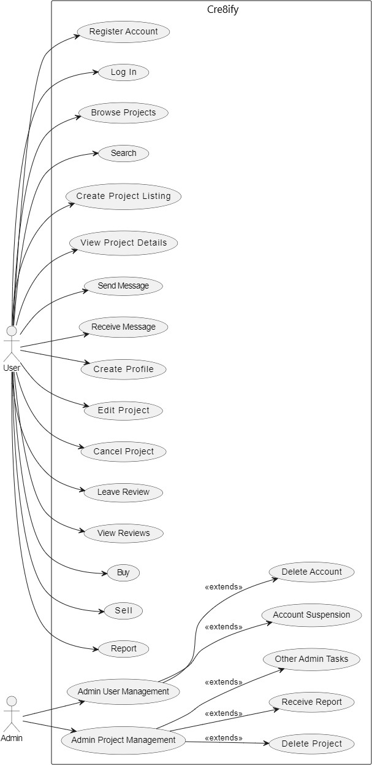

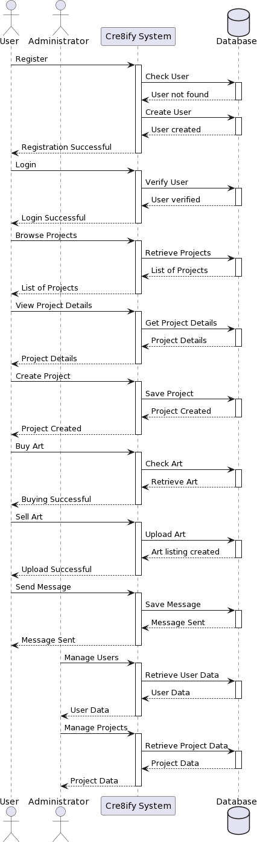**Sequence Diagram**

## HARDWARE AND SOFTWARE REQUIREMENT:

### Software Interface:

* + Front-end: HTML, CSS, JavaScript
  + Back-end: Python, Django
  + Database: SQLite, MongoDB

### Hardware Interface:

* + Computer or laptop with sufficient processing power (e.g., multi-core CPU).
  + Adequate RAM (8GB or more recommended).
  + Sufficient storage space for development tools, code repositories, and project assets.
  + High-resolution monitor for design and development tasks.
  + Internet connectivity for software downloads, collaboration, and testing.

## LIMITATIONS:

1. Limited Initial User Base: During the early stages, the platform may have a limited number of users and projects, which could affect the depth and variety of opportunities available to both creatives and clients.
2. Trust and Reputation: Building trust within the community is essential. Negative experiences or disputes between users could harm the platform's reputation.
3. Data Privacy and Security: Handling user data and financial transactions requires a strong focus on data privacy and security. Any data breaches or security incidents could have serious consequences.
4. Regulatory Compliance: The platform must comply with data protection regulations, intellectual property laws, and other legal requirements, which may vary by region.
5. Scalability: As the platform grows, scalability becomes a concern. Ensuring that the infrastructure can handle increased traffic and user volume is crucial.
6. Quality Control: Ensuring the quality of creative work can be difficult. The platform may need to implement measures to address issues related to the quality of projects and collaborations.
7. Dependency on Third-Party Services: Relying on third-party services, such as payment gateways or cloud hosting, can introduce dependencies and vulnerabilities.

## FUTURE SCOPE:

The future scope of this project is promising. Here are some potential areas of expansion and improvement:

* + Mobile Applications: Developing mobile apps for iOS and Android platforms can increase accessibility and user engagement.
  + Internationalization: Expanding the platform to support multiple languages and currencies can attract a global user base.
  + Advanced Collaboration Tools: Adding features like real-time collaboration tools for design and creative projects can enhance the platform's value.
  + AI-Powered Recommendations: Implementing AI algorithms for better user matching and project suggestions.
  + Diversification of Creative Services: Expanding beyond graphic design and branding to include services like web development, video production, and more can broaden the platform's appeal.
  + Community Building: Encouraging user-generated content, forums, and events can strengthen the sense of community among users.

## REFERENCES:

1. Official documentation for selected technologies and frameworks (e.g., Django, Python, Bootstrap).
2. Online coding tutorials and courses (e.g., Coursera, Udemy, freeCodeCamp)
3. Development communities like Stack Overflow for troubleshooting and problem-solving.